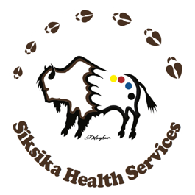

Siksika Health Services is developing a new Community Health Plan for Siksika Nation, called Pathways to Holistic Wellness. This work is community-led and community-informed, led by Siksika Health Services, guided by Siksika Nation Elders, and supported by MNP for program prioritization and plan development. The health and wellness of Siksika Nation is at the heart of this work, including the physical, mental, emotional, spiritual, and cultural well-being of our community members.

What Is “Pathways to Holistic Wellness”?
The Community Health Plan we are developing together will be a long-term plan to guide the health and wellness services that support Siksika Nation. It will be built on what our community members, Elders, children and youth, staff, and partners tell us matters most. The plan will:
- Provide a clear, practical roadmap to guide health and wellness services
- Reflect the voices, values, and priorities of the community
- Identify current gaps in services and opportunities to grow and improve
- Support care that is coordinated, culturally grounded, and respectful of Siksika ways of healing and wellness

Timeline
This initiative is unfolding in phases from April through the end of November 2026. Each phase includes opportunities for you and all community members to share your voice and perspectives, to hear from our partners and collaborators, to gather information, and make decisions together.

Your Role in This Work
Siksika Nation community members are encouraged to take the survey (options include one for community members ages 24+, and one for youth) and participate in upcoming engagement opportunities, including home visits, kitchen table discussions, and community events. Those who complete a survey and provide their contact information will be entered into a prize draw for some great prizes!

To complete a survey, visit https://siksikahealth.com/community-health-plan/.

Thank you, Siksika: your feedback and perspectives will help inform future planning and ensure community voices are reflected in this important work.

